EXPT NO:4 | Visual encoding of data
DATE: 20.01.2026 | Visual encoding of data

PRE-LAB QUESTIONS
- How does the human visual system process visual variables?

The human visual system quickly interprets visual variables such as position, color, size, and shape. In the R visualization, position shows accident location and severity, color represents severity, size indicates accident frequency, and shape distinguishes accident types. This combination enables fast pattern recognition with minimal cognitive effort.

- Why is improper encoding misleading in analytics?

Improper encoding can distort data interpretation. Incorrect color scales or size mappings may exaggerate or downplay accident severity and frequency, leading to false conclusions about high-risk zones and poor decision-making in traffic management.

- What are perceptual limitations in visualization?

Perceptual limitations include difficulty in comparing sizes, distinguishing similar colors, and handling excessive visual information. In traffic data visualization, overcrowding or poor color choices can reduce clarity, which is addressed using jittering, clear color contrast, and controlled point sizes.

- How does color choice affect interpretation?

Color strongly affects interpretation by conveying severity and urgency. Distinct colors for Minor, Major, and Fatal accidents make severity differences clear, while poor color contrast can confuse viewers or hide critical patterns.

- Why should AI dashboards be perceptually optimized?

AI dashboards present complex outputs that must be easily understood. Effective visual encoding using color, size, and shape improves clarity, reduces cognitive load, and helps users confidently interpret AI-generated insights.

OBJECTIVE: To apply effective visual encoding principles for meaningful data communication.
SCENARIO: A city traffic department analyzes accident data to identify high-risk zones and accident severity patterns.
IN-LAB TASKS (Using R Language) • Encode severity using color gradients • Represent accident frequency using size • Use shape to indicate accident type

Code:
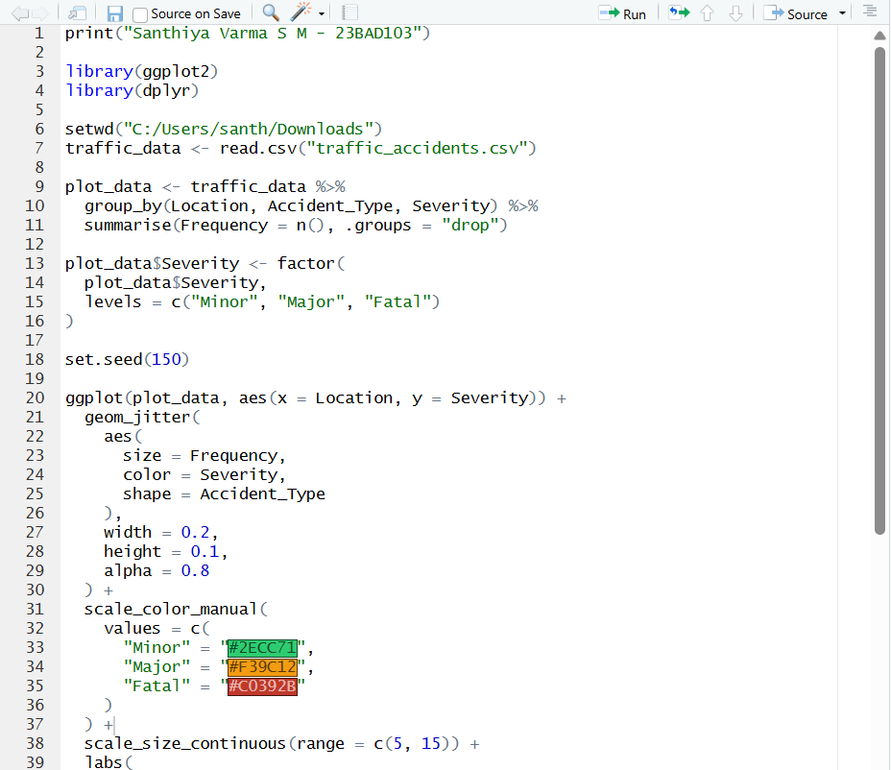
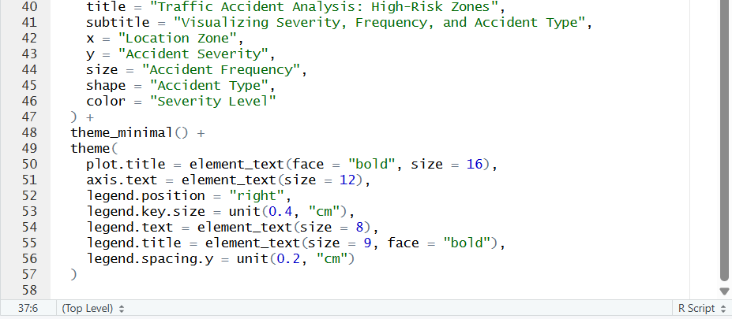

Output:

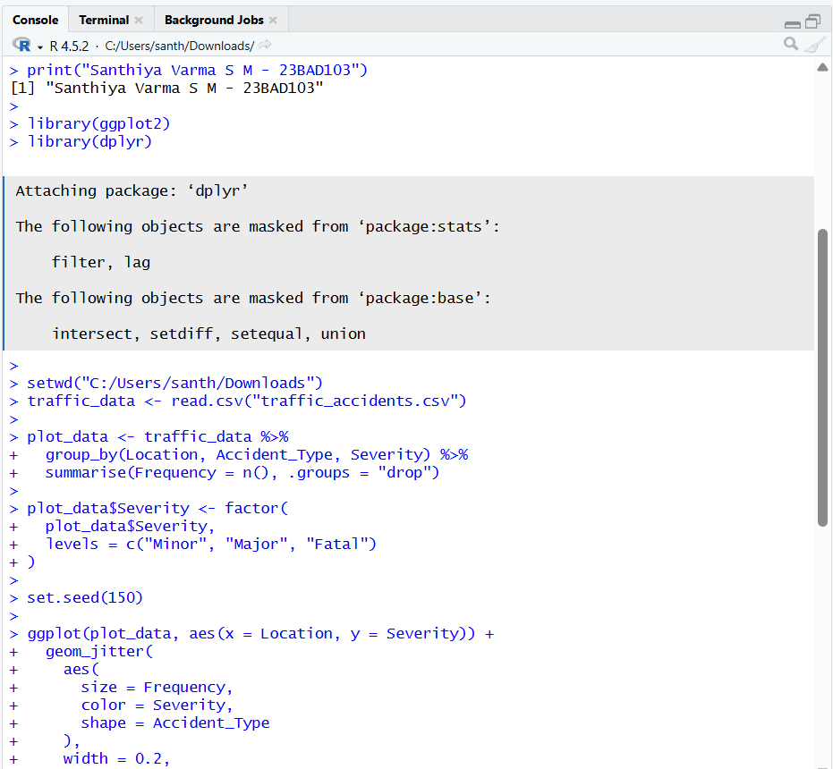
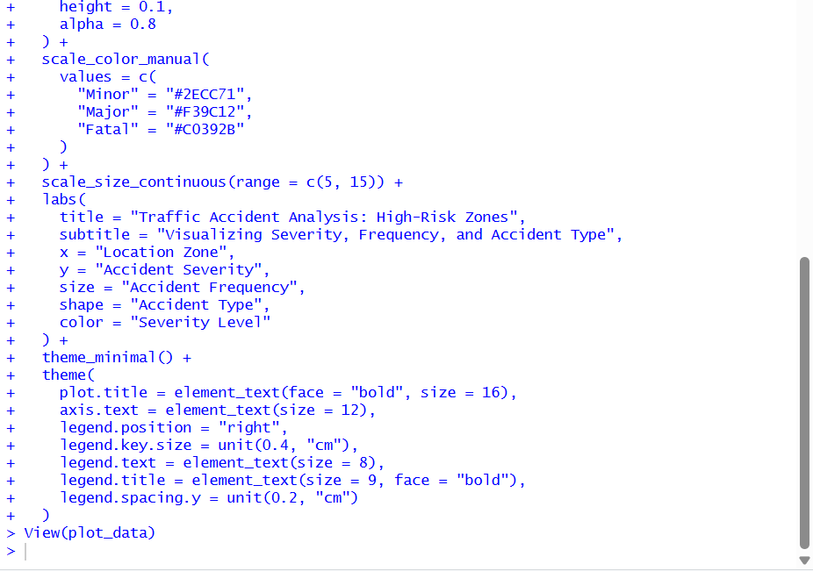

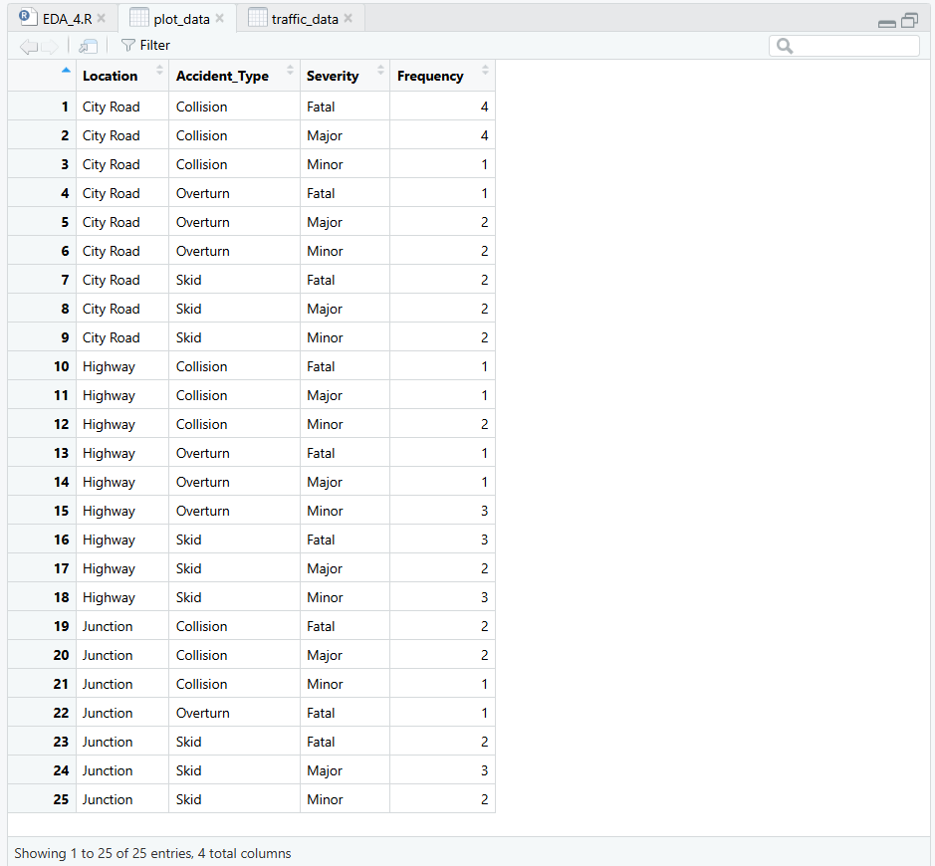

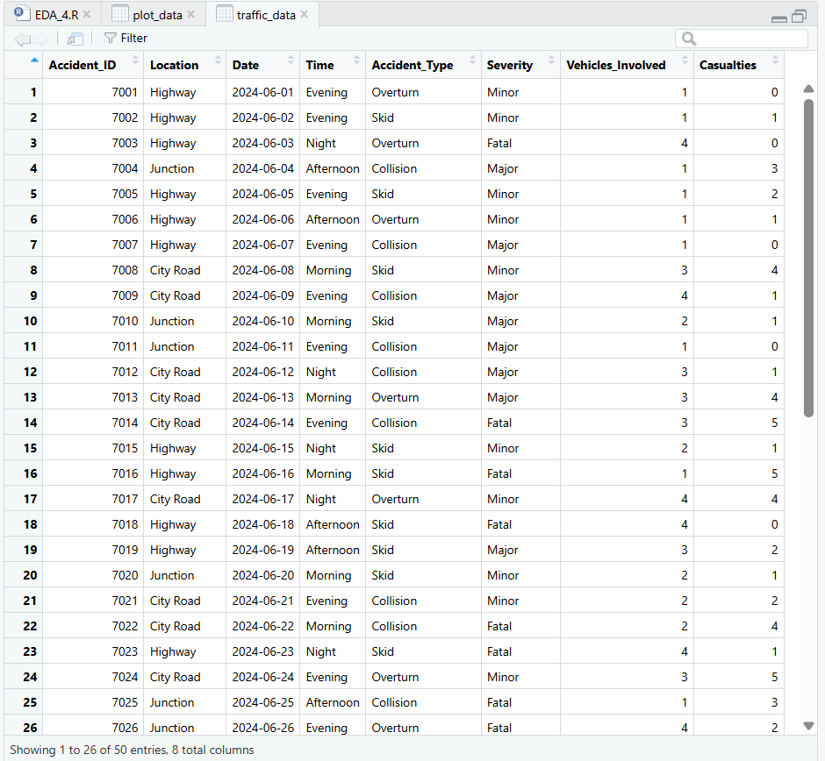

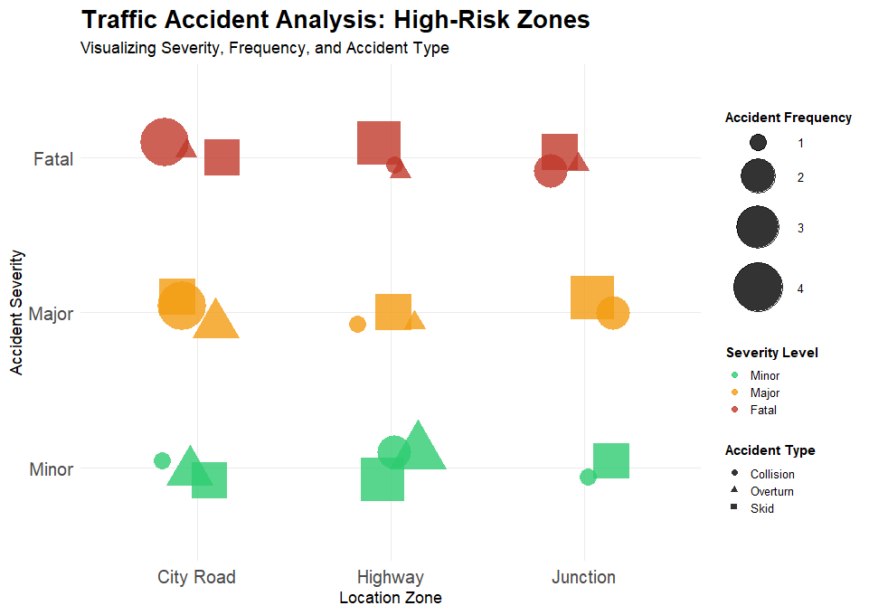

POST-LAB QUESTIONS
- Which visual variable best conveys severity and why?

Color best conveys severity because the human eye quickly detects differences in color intensity. In the visualization, distinct colors represent Minor, Major, and Fatal accidents, allowing users to easily recognize severity levels across locations. Color gradients also suit ordered categories, making interpretation intuitive.

- How can poor encoding mislead policy decisions?

Poor visual encoding can hide serious accident patterns or exaggerate minor ones. If high-severity accidents are not clearly emphasized using color or size, policymakers may underestimate risk zones. This can lead to inefficient resource allocation and delayed safety measures.

- What precautions should be taken for color-blind users?

Visualizations should avoid red–green color combinations and not rely on color alone. Using additional cues such as shape for accident type and size for frequency, along with clear legends and high-contrast palettes, ensures accessibility for color-blind users.

- How does visual encoding affect AI explainability?

Clear visual encoding converts complex AI outputs into understandable patterns. Representing severity, frequency, and accident types visually improves transparency, builds user trust, and helps both technical and non-technical users interpret AI insights.

- Suggest improvements for large-scale public dashboards.

Public dashboards should use consistent visual encoding and reduce clutter. Interactive features like filters and tooltips, along with readable legends and accessible layouts, help users explore and understand traffic risk patterns effectively.

LEARNING OUTCOME: Students learn perceptually effective visual communication for AI systems

ASSESSMENT
Description | Max Marks | Marks Awarded
Pre Lab Exercise | 5
In Lab Exercise | 10
Post Lab Exercise | 5
Viva | 10
Total | 30
Faculty Signature

